Status of Controls at the Top 167 Electric Generating Units (EGUs) that Contribute to
Visibility Impairment at
MANE-VU Class I Areas

Mid-Atlantic/Northeast Visibility Union
(MANE-VU)

DRAFT April 11, 2016

The Mid-Atlantic/Northeast Visibility Union (MANE-VU) identified 167 Electric Generating Units (EGUs) as sources that most affect visibility in the MANE-VU Class I areas. In establishing the reasonable progress goal for regional haze, MANE-VU Class I areas relied in part on implementation of emission reductions at the 167 EGU sources by 2018. These 167 EGU sources are located both within and outside MANE-VU.

The MANE-VU “Ask” requested a 90% or greater reduction in SO₂ emissions from 2002 levels at each of the 167 stacks identified by MANE-VU as contributing to visibility impairment at the MANE-VU Class I areas. If it is infeasible to achieve this level of reduction from a unit, the state could obtain the requested reduction from other units in the State.

The attached worksheets provide a summary of the status of controls at the 167 EGU units. New Jersey worked off of a previous analysis carried out by Maine to update the status of the controls at the units. Steps taken to update the worksheets are described as follows:

Step 1

The worksheet was updated with EGU control status from the National Electric Energy Data System (NEEDS) v5.14, and later NEEDS v5.15. The worksheet previously had control status information from NEEDS v4.10. The worksheet was also updated with Environmental Protection Agency’s (EPA) 2015 Clean Air Markets Division (CAMD) Air Markets Program Data (AMPD), updates from States (Georgia, Massachusetts, Maryland, Maine, New Hampshire, New Jersey, New York, North Carolina, Pennsylvania, and Virginia) and information from state SIPS (Ohio Regional Haze 5-Year Progress Report (January 2016)). “0” was assigned to units that had no values for SO₂ emissions in 2015 CAMD AMPD. Data from the Eastern Regional Technical Advisory Committee (ERTAC) was also reviewed to ensure consistency and accuracy.

Based on the information from the sources mentioned above, 45 out of the 167 units have been shut down, retired or decommissioned. The units eliminated are highlighted in grey in the tab “Retired_Shutdown_Decommissioned” in the spreadsheet “167 EGU Stacks that Impact MANE-VU Class I Areas” in Appendix X. These 45 units were eliminated in this step leaving 122 units.

Shawville is temporarily shut down to install equipment for burning natural gas. SO2 emissions are expected to be well below the 90% reduction expected at the Shawville units when they start burning natural gas. Shawville has retained its rights to burn coal, however, a federal regulation requires the installation of scrubbers before they can burn coal. The enforceability of the controls on these units should be investigated in the future as resources allow.

The 45 units that were eliminated in this step are listed in Table 1.

Table 1: Shut Down, Retired or Decommissioned Units (45 Units)

STATE | ORIS ID | PLANT NAME | UNIT ID
DELAWARE | 594 | INDIAN RIVER | 1
 |  |  | 2
 |  |  | 3
GEORGIA | 709 | HARLLEE BRANCH | 3,4
INDIANA | 988 | TANNER’S CREEK | U1,U2,U3
 |  |  | 4
MASSACHUSETTS | 1606 | MOUNT TOM | 1
 | 1613 | SOMERSET | 8
 | 1626 | SALEM HARBOR | 1
 |  |  | 3
 |  |  | 4
NEW JERSEY | 2378 | B L ENGLAND | 1
NEW YORK | 2526 | GOUDEY | 11,12,13
 | 2527 | GREENIDGE | 6
 | 2549 | C R HUNTLEY | 67,68
 |  |  | 63,64,65,66
 | 2554 | DUNKIRK | 3,4
 | 2594 | OSWEGO | 5
 | 2642 | ROCHESTER 7 | 3,4
NORTH CAROLINA | 2709 | LEE | 3
 | 2713 | L V SUTTON | 3
OHIO | 2830 | WALTER C BECKJORD | 6
 | 2832 | MIAMI FORT | 5-1,5-2,6
 | 2837 | EASTLAKE | 5
 | 2840 | CONESVILLE | 1,2
 | 2864 | R E BURGER | 5 THRU 8
 | 2872 | MUSKINGUM RIVER | 1,2,3,4
 |  |  | 5
 | 7253 | RICHARD GORSUCH | 1,2,3,4
PENNSYLVANIA | 3113 | PORTLAND | 1
 |  |  | 2
 | 3149 | MARTINS CREEK | 1,2
 | 3178 | ARMSTRONG | 2
 | 2179 | HATFIELD’S FERRY | 1,2
 | 3131 | SHAWVILLE | 3,4
SOUTH CAROLINA | 3319 | JEFFERIES | 3
 |  |  | 4
TENNESSEE | 3405 | JOHN SEVIER | 3,4
VIRGINIA | 3803 | CHESAPEAKE | 3
 |  |  | 4
WEST VIRGINIA | 3938 | KANAWHA RIVER | 1,2
 | 3938 | PHILIP SPORN | 51
 |  |  | 11,21,31,41
 | 3942 | ALBRIGHT | 3
 | 3947 | KAMMER | 1,2,3

Step 2

The remaining 122 units were reviewed for units that have 90% or greater SO₂ emission reductions from 2002 total SO₂ stack level emissions. The emission reduction was based on emissions reported as 2015 CAMD AMPD SO₂ stack level data. These units met the MANE-VU Ask at the stack level for a 90% or greater reduction. 83 units met this criterion, and were eliminated, leaving 39 units. The units eliminated are highlighted in light green in the tab “90%+Reduction” in the spreadsheet “167 EGU Stacks that Impact MANE-VU Class I Areas” in Appendix X. The 83 units that were eliminated are listed in Table 2.

Table 2: Units with 90% or Greater SO₂ Emission Reductions (2002-2015) (83 Units)

STATE | ORIS ID | PLANT NAME | UNIT ID
DELAWARE | 593 | EDGE MOOR | 5
 | 594 | INDIAN RIVER | 4
GEORGIA | 703 | BOWEN | 1BLR
 |  |  | 2BLR
 |  |  | 3BLR
 |  |  | 4BLR
ILLINOIS | 861 | COFFEEN | 1,2
INDIANA | 990 | ELMER W STOUT | 70
 | 1001 | CAYUGA | 1
 |  |  | 2
 | 1008 | R GALLAGHER | 1,2
 |  |  | 3,4
 | 6113 | GIBSON | 1,2
 | 6705 | WARRICK | 1,2
 |  |  | 4
KENTUCKY | 1355 | E W BROWN | 2,3
 | 1378 | PARADISE | 3
 | 1384 | COOPER | 1,2
 | 6041 | H L SPURLOCK | 1
 |  |  | 2
MARYLAND | 602 | BRANDON SHORES | 1
 |  |  | 2
 | 1552 | C P CRANE | 1
 |  |  | 2
 | 1571 | CHALK POINT | 1,2
 | 1572 | DICKERSON | 1,2,3
 | 1573 | MORGANTOWN | 1
 |  |  | 2
MASSACHUSETTS | 1599 | CANAL | 1
 |  |  | 2
 | 1619 | BRAYTON POINT | 1
 |  |  | 2
 |  |  | 3
MICHIGAN | 1702 | DAN E KARN | 3,4
 | 1733 | MONROE | 1,2
 |  |  | 3,4
NEW HAMPSHIRE | 2364 | MERRIMACK | 1
 |  |  | 2
 | 8002 | NEWINGTON | 1
NEW JERSEY | 2403 | HUDSON | 2
 | 2408 | MERCER | 1
 |  |  | 2
NEW YORK | 2480 | DANSKAMMER | 4
 | 2516 | NORTHPORT | 3
 | 8006 | ROSETON | 1
NORTH CAROLINA | 2712 | ROXBORO | 3A,3B
 | 2721 | CLIFFSIDE | 5
 | 2727 | MARSHALL | 3
 |  |  | 4
 | 6250 | MAYO | 1A,1B
 | 8042 | BELEWS CREEK | 1
 |  |  | 2
OHIO | 2828 | CARDINAL | 3
 | 2832 | MIAMI FORT | 7
 | 2840 | CONESVILLE | 4
 | 2850 | J M STUART | 1
 |  |  | 2
 |  |  | 3
 |  |  | 4
 | 2866 | W H SAMMIS | 1,2
 |  |  | 3,4
 |  |  | 5
 |  |  | 6
 |  |  | 7
 | 2876 | KYGER CREEK | 1,2,3,4,5
PENNSYLVANIA | 3149 | MONTOUR | 1
 | 8226 | CHESWICK | 1
SOUTH CAROLINA | 3297 | WATEREE | WAT1
 |  |  | WAT2
 | 3298 | WILLIAMS | WIL1
 | 6249 | WINYAH | 1
TENNESSEE | 3407 | KINGSTON | 1,2,3,4,5
 |  |  | 6,7,8,9
VIRGINIA | 3775 | CLINCH RIVER | 1,2
 | 3797 | CHESTERFIELD | 4
 |  |  | 5
 |  |  | 6
WEST VIRGINIA | 3935 | JOHN E AMOS | 1,2
WEST VIRGINIA | 3935 | JOHN E AMOS | 3
 | 3943 | FORT MARTIN | 1
 |  |  | 2
 | 3948 | MITCHELL | 1,2
 | 6264 | MOUNTAINEER | 1

Step 3

The remaining 39 units were further reviewed for units that have scrubbers with at least 90% scrubber control efficiency. This was done on a case by case basis. SO₂ emission reductions at these units were between 85 and 89% in 2015 compared to 2002 levels. Some of these units had over 90% SO₂ emission reductions in 2014 but could have differed because of variations in amount of the unit’s operation between later years and the 2002 base year. Units with wet scrubbers that were installed prior to 2002 were also eliminated even though some of them have emission reductions less than 85% when the wet scrubbers reported scrubber control efficiency of well over 90%. This could be as a result of how the scrubber was used; scrubber shut downs or inactivity, or emission reductions that may have already taken place before 2002. It could also be due to meteorological changes. In this step, 13 Units were eliminated, leaving 26. The units eliminated are highlighted in purple in the tab “Scrubber90%+” in the spreadsheet “167 EGU Stacks that Impact MANE-VU Class I Areas” in Appendix X. The 13 units that were eliminated are listed in Table 3.

Table 3: Units with Scrubbers with 90% or Higher Scrubber Efficiency
SO₂ Emission Reductions: 85%-89% (2002-2015) (13 Units)

STATE | ORIS ID | PLANT NAME | UNIT ID
INDIANA | 983 | CLIFTY CREEK | 1,2,3
 |  |  | 4,5,6
 | 6113 | GIBSON | 3,4
KENTUCKY | 1364 | MILL CREEK | 4
 | 6018 | EAST BEND | 2
NORTH CAROLINA | 2712 | ROXBORO | 1
 |  |  | 2
 |  |  | 4A,4B
OHIO | 2828 | CARDINAL | 1
PENNSYLVANIA | 3136 | KEYSTONE | 1
 | 3140 | BRUNNER ISLAND | 1,2
 |  |  | 3
 | 3149 | MONTOUR | 2

Step 4

In this step, the remaining 26 units were reviewed for units that have scrubbers (both wet and dry) installed. Dry scrubbers are believed to be less efficient than wet ones (generally below 80% emission reduction), but according to a USEPA Air Pollution Control Technology fact sheet, newer dry scrubbers are capable of higher control efficiencies, on the order of 90%. Some of the units that were eliminated in this step had scrubbers with 90% or higher efficiency but SO₂ emission reductions at these units in 2015 were less than 85% compared with 2002 levels. 14 units were eliminated in this step, leaving 12. The units eliminated are highlighted in blue in the tab “Scrubbers” in the spreadsheet “167 EGU Stacks that Impact MANE-VU Class I Areas” in Appendix X. The 14 units that were eliminated are listed in Table 4.

Table 4: Units with Scrubbers (Wet and Dry)
SO₂ Emission Reductions: < 85% (2002-2015) (14 Units)

STATE | ORIS ID | PLANT NAME | UNIT ID*
KENTUCKY | 1356 | GHENT | 3,4
 | 1378 | PARADISE | 2
OHIO | 2828 | CARDINAL | 2
 | 2866 | W H ZIMMER | 1
 | 6031 | KILLEN STATION | 2
 | 8102 | GEN J M GAVIN | 1
 |  |  | 2
PENNSYLVANIA | 3122 | HOMER CITY | 1
 |  |  | 2
 | 3136 | KEYSTONE | 2
TENNESSEE | 3403 | GALLATIN | 3,4
WEST VIRGINIA | 3954 | MT STORM | 1,2
 | 6004 | PLEASANTS | 1
 |  |  | 2
⃰ It is recommended that these units be revisited to determine why their emissions are lower than expected.

Step 5

Units that have plans to retire or install newer controls by 2018 were eliminated in this step. Determinations were made based on updates from states and information from NEEDS v5.15. Five out of the remaining 12 units were eliminated, leaving 7 that will not meet the MANE-VU “Ask” by 2018. The units that were eliminated are highlighted in orange in the tab “Plans to Retire_Control” in the spreadsheet “167 EGU Stacks that Impact MANE-VU Class I Areas” in Appendix X. The 5 units that were eliminated in this step are listed in Table 5.

Table 5: Units with Plans to Retire or Install Newer Controls by 2018 (5 Units)

STATE | ORIS ID | PLANT NAME | UNIT ID
INDIANA | 1010 | WABASH RIVER | 2,3,4,5,6
 | 6166 | ROCKPORT | MB1,MB2
MAINE | 1507 | WILLIAM F WYMAN | 4
TENNESSEE | 3406 | JOHNSONVILLE | 1 THRU 10
VIRGINIA | 3809 | YORKTOWN | 1,2

Step 6

The remaining 7 units were further reviewed for the quantity of SO₂ in pounds (lbs.) burned per Heat Input in MMBtu. This analysis was done using 2015 CAMD AMPD data. 0.1 – 0.4 was chosen as the acceptable rate. 1 unit was eliminated, leaving 6 units having higher SO₂ emissions than others. The unit that was eliminated is highlighted in brown in the tab “Heat Input” in the spreadsheet “167 EGU Stacks that Impact MANE-VU Class I Areas” in Appendix X. The unit that was eliminated is listed in Table 6.

Table 6: Units with SO₂ (lbs) Burned per Heat Input (MMBtu) Between 0.1-0.4 (1 Unit)

STATE | ORIS ID | PLANT NAME | UNIT ID
NEW YORK | 8006 | ROSETON | 2

Step 7

The remaining 7 units were ranked from highest to lowest based on total stack level SO₂ emissions using 2015 CAMD AMPD. These units do not seem to have sufficient SO₂ controls installed. These 7 units are listed in the tab “Rank” in the spreadsheet “167 EGU Stacks that Impact MANE-VU Class I Areas” in Appendix X, and are also listed in Table 7.

Table 7: Units with Insufficient SO2 Controls (6 Units)

Plant | State | UNIT ID | ORIS ID | 2015 CAMD SO₂ (tpy) | 2002 CAMD SO₂ (tpy) | % Change 2002-2015
Avon Lake | OH | 12 | 2836 | 47,964 | 41,840 | 15%
Big Sandy | KY | BSU1 | 1353 | 21,852 | 41,899 | -41%
Trenton Channel | MI | 9A | 1745 | 11,656 | 19,237 | -39%
St. Clair | MI | 7 | 1743 | 8,938 | 15,980 | -44%
Herbert A Wagner | MD | 3 | 1554 | 8,751 | 10,096 | -48%
Yorktown | VA | 3 | 3809 | 2,070 | 10,567 | -80%

Note that Avon Lake in Ohio has a 15% increase in emissions from 2002 levels.
A map showing the locations of the 167 EGU units and their status is shown in Figure 1.

Figure 1: Status of Controls at Top 167 EGUs:
Contribution to Visibility Impairment
at MANE-VU Class I Areas
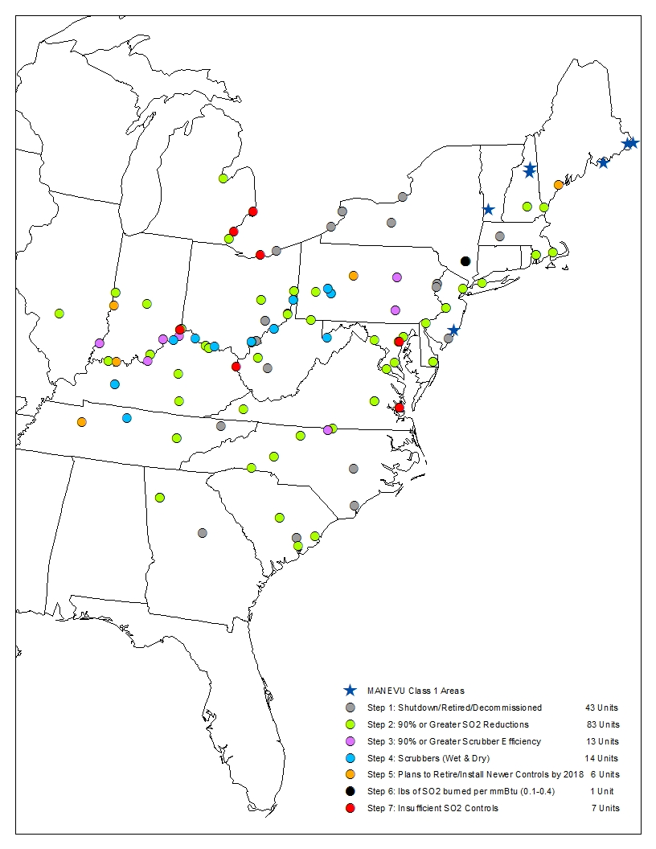

http://www.epa.gov/airmarkets/power-sector-modeling-platform-v515 (Accessed February 22, 2016)
http://ampd.epa.gov/ampd/ (Accessed February 25, 2016)
http://www3.epa.gov/ttncatc1/dir1/ffdg.pdf (Accessed March 3, 2016)

